Paul M. Summitt
312 Proctor Drive
Columbia, MO 65202
573-268-7209
Forgotten Missouri Pioneer Women
Two Kentucky Summitt Sisters and their daughters

Chapter 1
George Summitt¹

George Summitt was born around the year 1765² in Berkes County in the state of Pennsylvania somewhere near Philadelphia³. His parents were Christian Summitt and Maria Stahlern⁴.
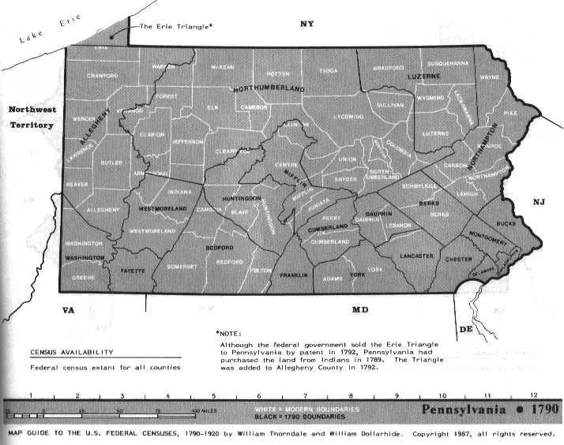
Christian more than likely arrived in Philadelphia from Germany on September 10, 1753 with his father, Jacob Summitt (Sammit). Only heads of households were listed by Captain Richey of the Ship Beulah so neither Jacob's wife nor his unmarried children would have been listed on the ship's entry documents. The list of these heads included eight Catholics and the rest, including Jacob, Lutherans. As Christian was born about 1735, he would have been around 17 or 18 in 1753 at the time of the family's arrival.
According to the "Early Records of the First Reformed Church of Philadelphia; Volume 1; 1748-1780," Christian married Maria Stahlern in Philadelphia on April 27, 1755. He would have been about twenty at that time. Christian's first daughter that we are aware of, Maria Gertrand Summitt (Summit), was born five years later on March 13, 1760 and baptized at Trinity Lutheran Church in Reading in Berkes County. Christian's first son that we are aware of, John, was born in Berkes County in 1761. Another daughter, Susanna, is listed in the Trinity records as being born March 30, 1765 and baptized April 17, 1765. Christian's son George is also estimated to have been born about 1765.
Jacob Summitt (Summit) is listed on the tax rolls in Berkes County in 1767 and in 1769 the father of Rosanna Summitt (Summit) is listed as Jacob Summitt (Summit) of Virginia. At the time of her marriage to John Swank, Rosanna was about sixteen.
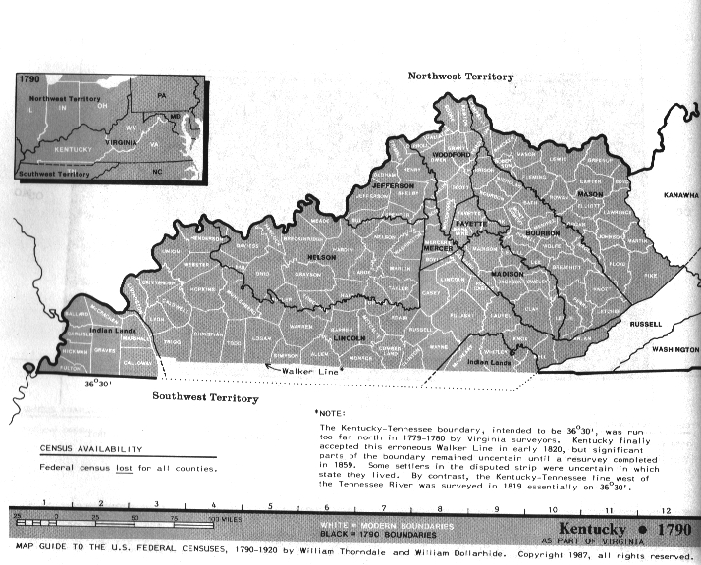
While it may appear confusing, this area, that would later become parts of Pennsylvania, Kentucky, West Virginia, and Virginia, was in dispute between the colonies of Pennsylvania and Virginia during this time period. In August of 1778, Jacob would be given a land grant by Lord Fairfax in the Northern Neck of Virginia in Hampshire County, an area that is now West Virginia. Christian Summitt (Summit) is found in Virginia court records for an area now covered by Washington County, Pennsylvania in a slander suit that ran from August 1777 through August of 1778.
In 1780, fifteen year old George Summitt was living at Grant's Station in Kentucky. Located in Bourbon County, near the Fayette County line, the fort was build in 1779 only to be partially destroyed during an Indian attack in June of 1780. In a letter dated April 24, 1780, John Grant, founder of Grant's Station, wrote that George was living at Grant's Station in 1780, visited Sturgus Station on Bear Grass, also in 1780, and raised a crop of corn there. George was in the area of the Lower Blue Tick in 1782⁵.
Christian's name appears on a petition to the Virginia Legislature requesting that mills be allowed to be constructed on the Licking River in Kentucky in 1790⁶. Christian also appears in an 1800 Kentucky tax list⁷. Both Christian and George appear in Nicholas County during the 1810 Census. Christian died some time around 1815 but George is listed in both the 1820 and 1830 census there in Nicholas County and after dying 03 May 1838, is buried in the Summitt-Snapp Cemetery near Walnut Grove in Nicholas County.

Chapter Notes
- In various documents this last name is spelled in a variety of ways including Summitt, Summit, Sammet, Sammit, and Shumate just to name a few. For clarity in this document, the author has decided to spell it the same as his own but will notate the different spellings in the various documents.
- In a deposition George Summitt made and filed in Franklin Co., Kentucky, he stated that he was forty years old and came to Kentucky in 1780. Source: Ardery, Kentucky Court and Other Records, Vol. 2, p. 141. [Franklin County was not formed until 1795] As the date of the deposition was November 11, 1805, this would suggest his date of birth fell some time between November 12, 1764 and November 10, 1765.
- While some records suggest George was born in Westmoreland County, Pennsylvania, according to "Trinity Lutheran, Reading, Pennsylvania An Alphabetized Compilation of Baptisms, Marriages, and Deaths from 1751-1904" Prepared by Jacqueline B Nein and Gail H Hesser; 1988, Christian and Maria were in Berkes County for the baptism of their daughter Suzanna as late as April 17, 1765 who had been born on March 30, 1765. This would suggest he was more than likely born in Berkes County.
- In 1783 Christian receives a land grant of 325 acres from Virginia in Fayette County, Kentucky [Book 8, p. 47. Surveyed 1-7-1783. Watercourse: Hinkston Fork. Jillson, Old Kentucky Entries and Deeds, p. 150]. In 1814, a year before his death, Christian sells 325 acres to George and a Peter Snap (Deed recorded in deed Book "D", p. 145-149). Peter is the brother of Margaret Snap, wife of John Summitt, Christian's oldest son. As George had been on this land at least since 1784 when he built Summitt Station, it is probable that George is John Summitt's younger brother and Christian Summitt's son.
- Http://www.frontierfolk.org/grantsfort.htm.
- Robertson, James Rood,. Petitions of the early inhabitants of Kentucky to the General Assembly of Virginia : 1769-1792. Louisville, Ky.: J.P. Morton & Co., printers to the Filson Club, 1914.
- Jackson, Ron V., Accelerated Indexing Systems, comp.. Kentucky Census, 1810-90 [database on-line]. Provo, UT, USA: Ancestry.com Operations Inc, 1999. Original data: Compiled and digitized by Mr. Jackson and AIS from microfilmed schedules of the U.S. Federal Decennial Census, territorial/state censuses, and/or census substitutes.

